**OBJECT ORIENTED PROGRAMMING LAB**



Name – BHAVYA TALWAR

SAP ID – 500121992

Course – BTech CSE AIML

BATCH-03

Submitted To– Mr. Saurabh Jain

**Experiment – 09**

**TITLE: Multithreading**

1. “Write a program to implement the concept of multithreading by extending the Thread class.”

**Code:**

class Thread1 extends Thread {

    public void run() {

        for (int i = 0; i < 5; i++) {

            System.out.println("Thread 1 is running: " + (i + 1));

        }

    }

}

class Thread2 extends Thread {

    public void run() {

        for (int i = 6; i <= 10; i++) {

            System.out.println("Thread 2 is running: " + i);

        }

    }

}

class ques1 {

    public static void main(String[] args) {

        Thread1 t1 = new Thread1();

        t1.start();

        Thread2 t2 = new Thread2();

        t2.start();

        System.out.println("Bhavya Talwar");

        System.out.println("500121992");

    }

}

**Output:**

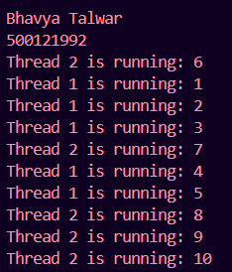

1. “Write a program to implement the concept of multithreading by implementing a Runnable interface.”

**Code:**

class Thread3 implements Runnable {

    public void run() {

        for (int i = 0; i < 5; i++) {

            System.out.println("Thread 1 is running: " + (i + 1));

        }

    }

}

class Thread4 implements Runnable {

    public void run() {

        for (int i = 6; i <= 10; i++) {

            System.out.println("Thread 2 is running: " + i);

        }

    }

}

class ques2 {

    public static void main(String[] args) {

        Thread3 t1 = new Thread3();

        Thread t3 = new Thread(t1);

        t3.start();

        Thread4 t2 = new Thread4();

        Thread t4 = new Thread(t2);

        t4.start();

        System.out.println("Bhavya Talwar");

        System.out.println("500121992");

    }

}

**Output:**

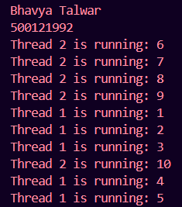

1. “Write a program for generating 2 threads, one for printing even numbers and the other for printing odd numbers.”

**Code:**

import java.util.Scanner;

class Thread1 extends Thread {

    int n;

    Thread1(int n) {

*this*.n = n;

    }

    public void run() {

        for (int i = 0; i <= n; i++) {

            if (i % 2 == 0) {

                System.out.println("Thread 1 is even: " + i);

            }

        }

    }

}

class Thread2 extends Thread {

    int n;

    Thread2(int n) {

*this*.n = n;

    }

    public void run() {

        for (int i = 0; i <= n; i++) {

            if (i % 2 != 0) {

                System.out.println("Thread 2 is odd: " + i);

            }

        }

    }

}

class ques3 {

    public static void main(String[] args) {

        System.err.print("Enter the limit: ");

        Scanner sc = new Scanner(System.in);

        int n = sc.nextInt();

        Thread1 t1 = new Thread1(n);

        t1.start();

        Thread2 t2 = new Thread2(n);

        t2.start();

        System.out.println("Bhavya Talwar");

        System.out.println("500121992");

    }

}

**Output:**

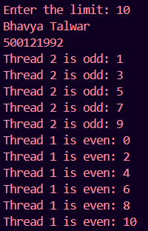

1. “Write a Java program that implements multithreading among 3 threads. Use sleep() and join() methods and show appropriate output.”

**Code:**

class Thread1 extends Thread {

    public void run() {

        for (int i = 0; i < 3; i++) {

            System.out.println("Thread 1 is running: " + (i + 1));

        }

        try {

            Thread.sleep(1000);

        } catch (Exception e) {

            System.out.println(e);

        }

    }

}

class Thread2 extends Thread {

    public void run() {

        for (int i = 0; i < 3; i++) {

            System.out.println("Thread 2 is running: " + (i + 1));

        }

        try {

            Thread.sleep(1000);

        } catch (Exception e) {

            System.out.println(e);

        }

    }

}

class Thread3 extends Thread {

    public void run() {

        for (int i = 0; i < 3; i++) {

            System.out.println("Thread 3 is running: " + (i + 1));

        }

        try {

            Thread.sleep(1000);

        } catch (Exception e) {

            System.out.println(e);

        }

    }

}

class ques4 {

    public static void main(String[] args) {

        Thread1 t1 = new Thread1();

        Thread2 t2 = new Thread2();

        Thread3 t3 = new Thread3();

        System.out.println("Thread-1 Started");

        t1.start();

        try {

            t1.join();

        } catch (Exception e) {

            System.out.println(e);

        }

        System.out.println("Thread-1 Finished");

        System.out.println("Thread-2 Started");

        t2.start();

        try {

            t2.join();

        } catch (Exception e) {

            System.out.println(e);

        }

        System.out.println("Thread-2 Finished");

        System.out.println("Thread-3 Started");

        t3.start();

        try {

            t3.join();

        } catch (Exception e) {

            System.out.println(e);

        }

        System.out.println("Thread-3 Finished");

        System.out.println("Bhavya Talwar");

        System.out.println("500121992");

    }

}

**Output:**

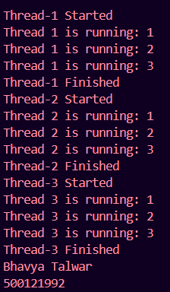

1. “Write a Java program that shows multithreading between three threads. Set different priorities for each thread and show output.”

**Code:**

class Thread1 extends Thread {

    public void run() {

        for (int i = 0; i < 5; i++) {

            System.out.println("Thread 1 is running: " + (i + 1));

        }

    }

}

class Thread2 extends Thread {

    public void run() {

        for (int i = 6; i <= 10; i++) {

            System.out.println("Thread 2 is running: " + i);

        }

    }

}

class Thread3 extends Thread {

    public void run() {

        for (int i = 11; i <= 15; i++) {

            System.out.println("Thread 3 is running: " + i);

        }

    }

}

class ques5 {

    public static void main(String[] args) {

        Thread1 t1 = new Thread1();

        Thread2 t2 = new Thread2();

        Thread3 t3 = new Thread3();

        t1.setPriority(Thread.MIN_PRIORITY);

        t2.setPriority(Thread.MAX_PRIORITY);

        t3.setPriority(Thread.NORM_PRIORITY);

        System.out.println("Priority Value of t1 thread=" + t1.getPriority());

        System.out.println("Priority Value of t2 thread=" + t2.getPriority());

        System.out.println("Priority Value of t3 thread=" + t3.getPriority());

        t1.start();

        t2.start();

        t3.start();

        System.out.println("Bhavya Talwar");

        System.out.println("500121992");

    }

}

**Output:**

